**Nama : Dini Tri Widianingsih**

**No. Peserta : FSDO003ONL007**

**DOKUMENTASI SESI 13**

**DEPLOYMENT**

Deployment menggunakan Docker Dan Heroku

* Butal Folder baru bernama DiniWeatherTest
* Buat file baru yaitu Dockerfile lalu Build

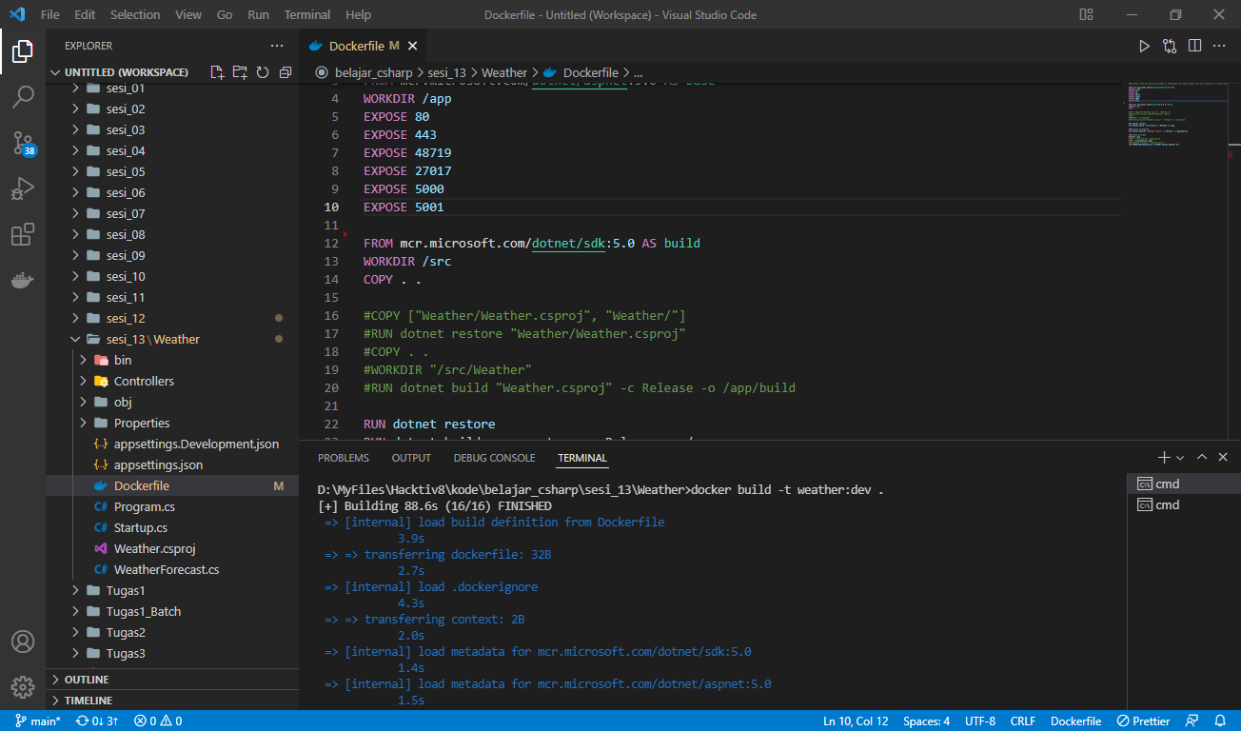

* Jalankan Syntax berikut :

dotnet build

dotnet publish -c Release

docker build -t weatherimage:dev .

docker run -d -p 5051:80 --name weathercontainer weatherimage:dev

((jika berhasil akan muncul weatherimagedini di dalam docker))

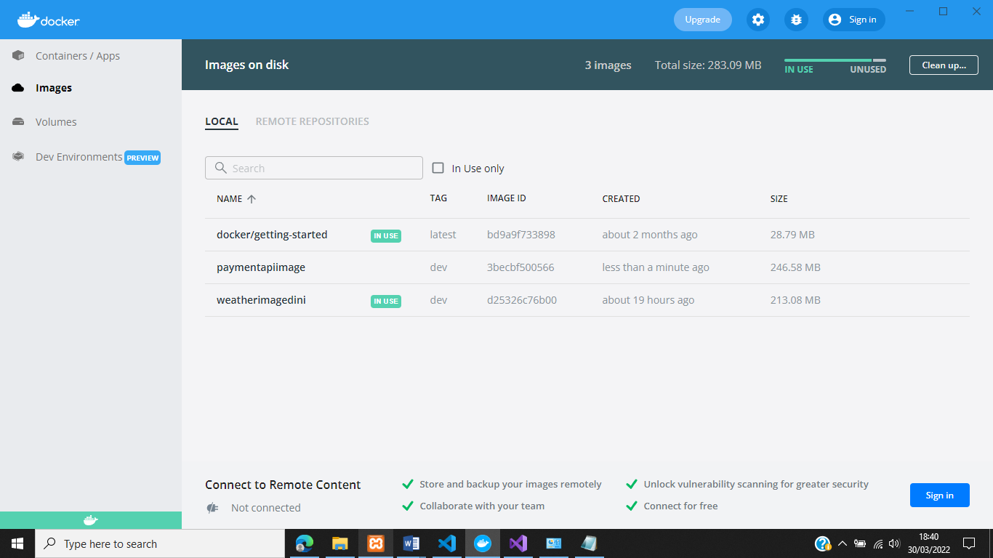

**SWAGGER**

* Tampilan Awal Swagger

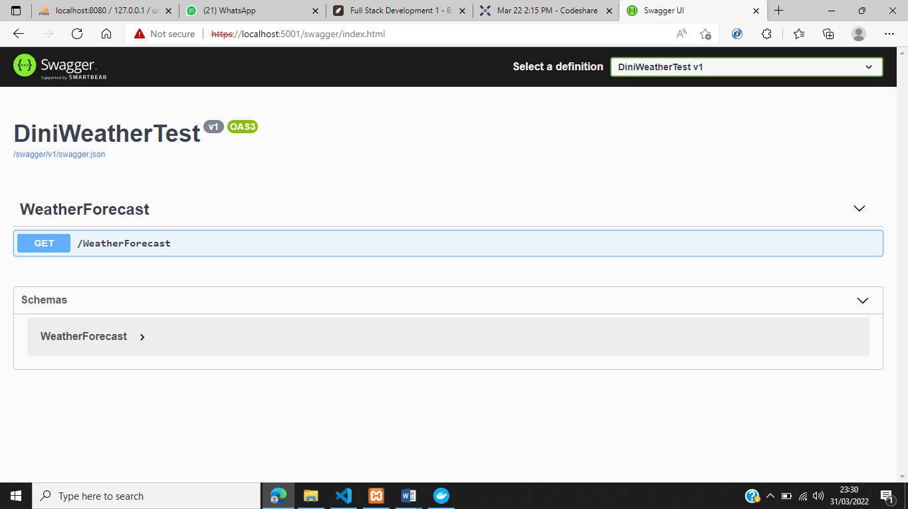

**GET** : WEATHERFORECAST

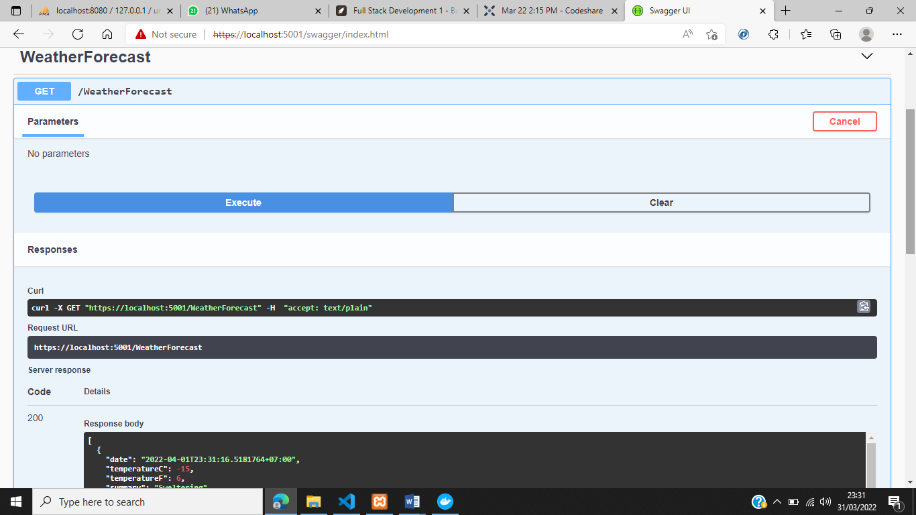

**GITHUB** : [dinni26/DiniWeatherTest (github.com)](https://github.com/dinni26/DiniWeatherTest)

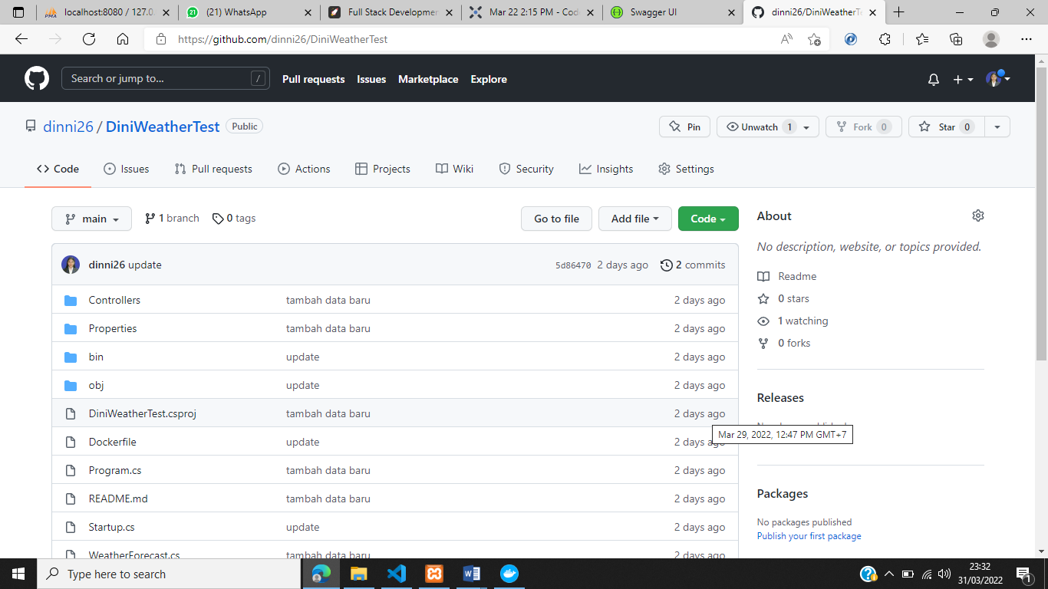

**DEPLOY WITH HEROKU**

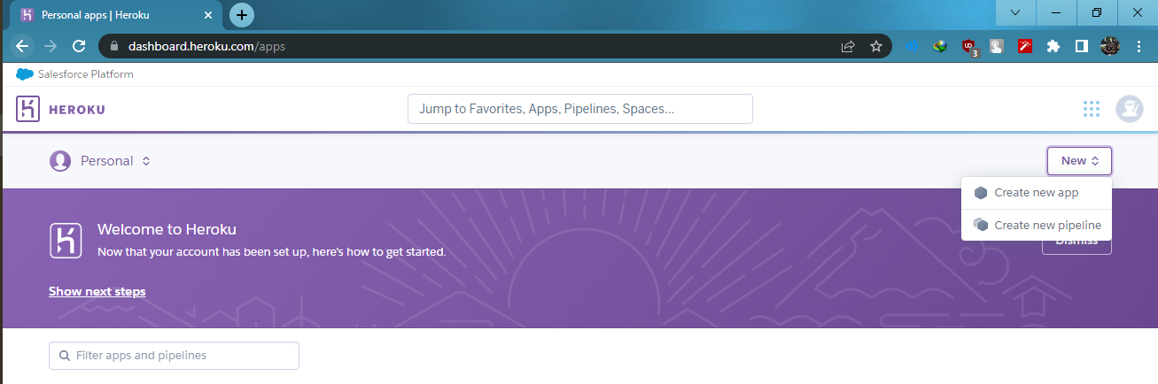

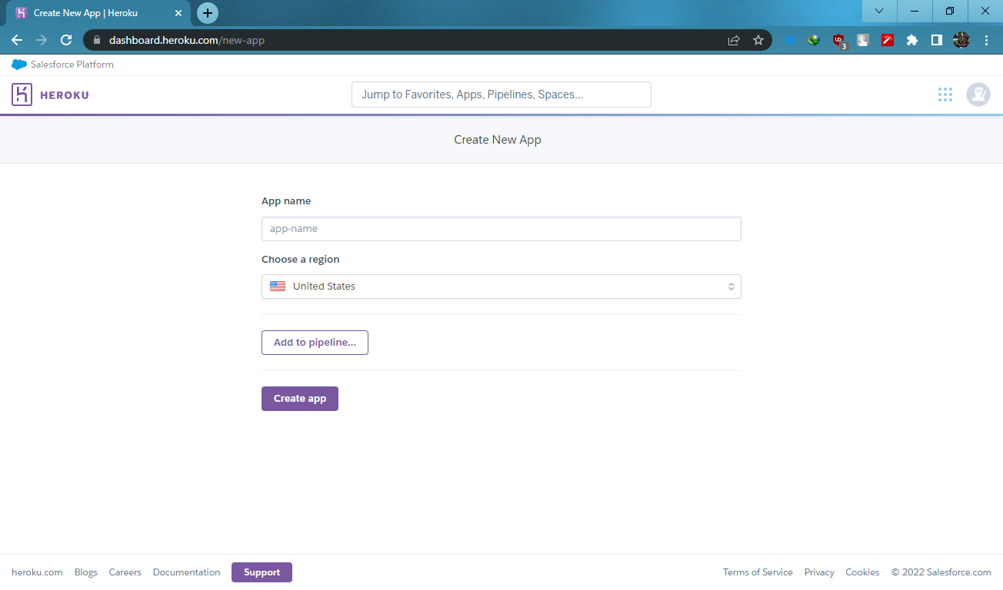

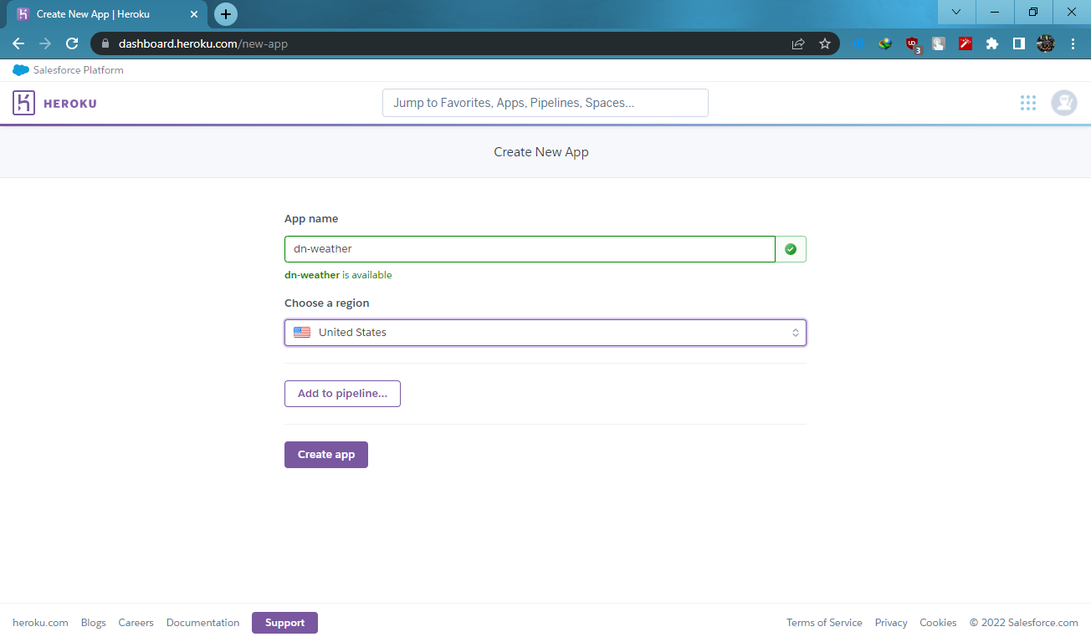

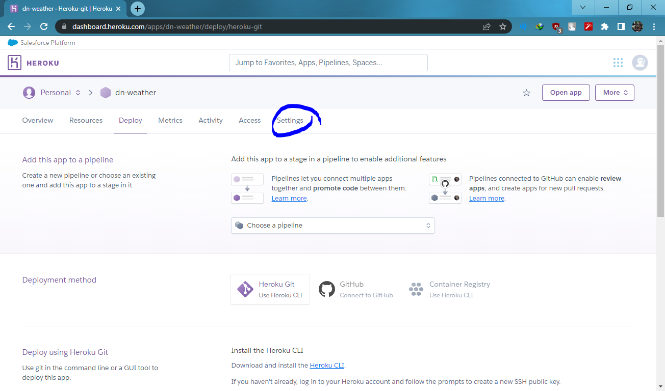

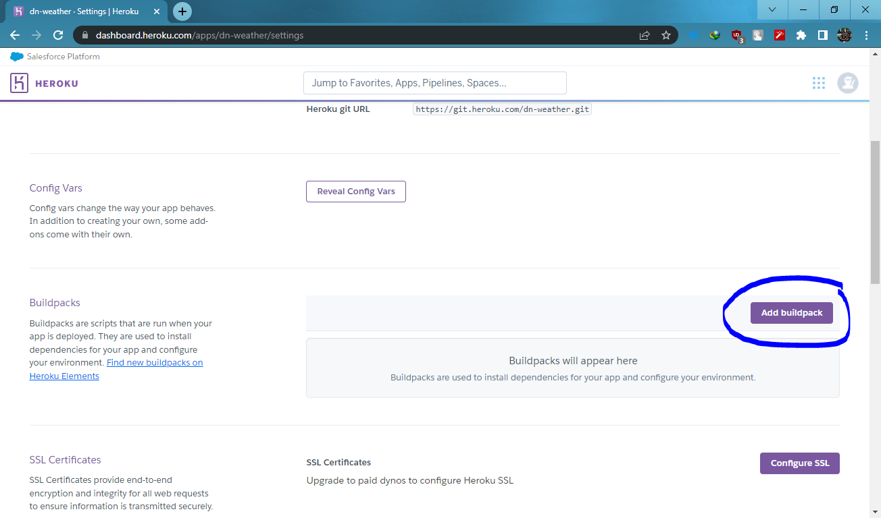

Masukan Link Gincod : <https://github.com/jincod/dotnetcore-buildpack.git>

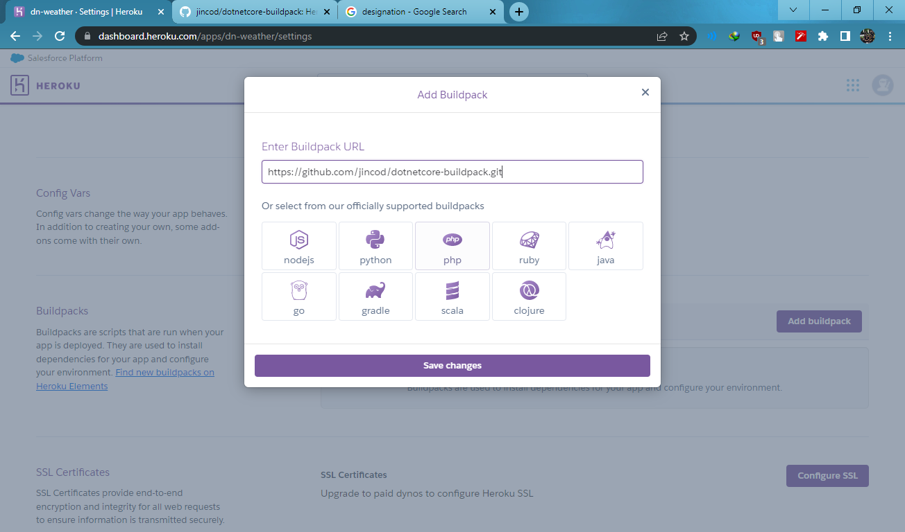

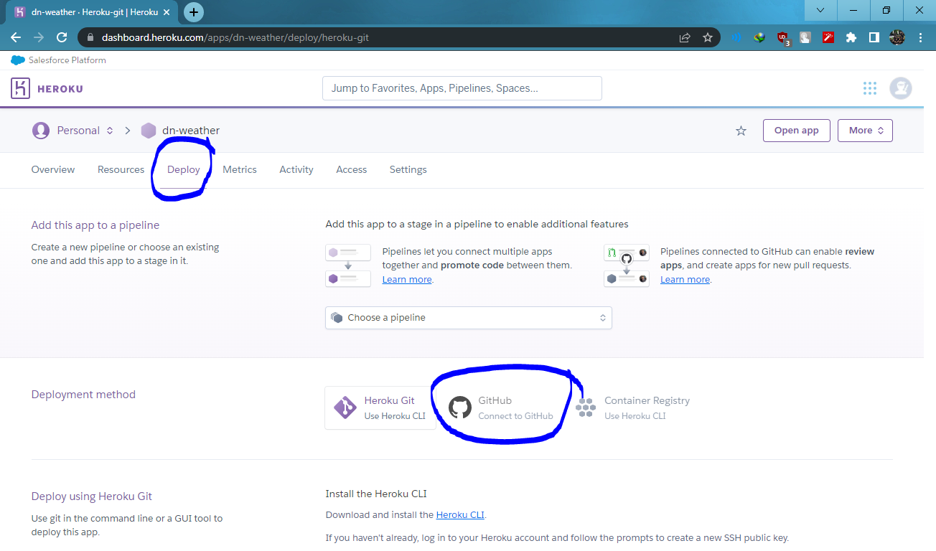

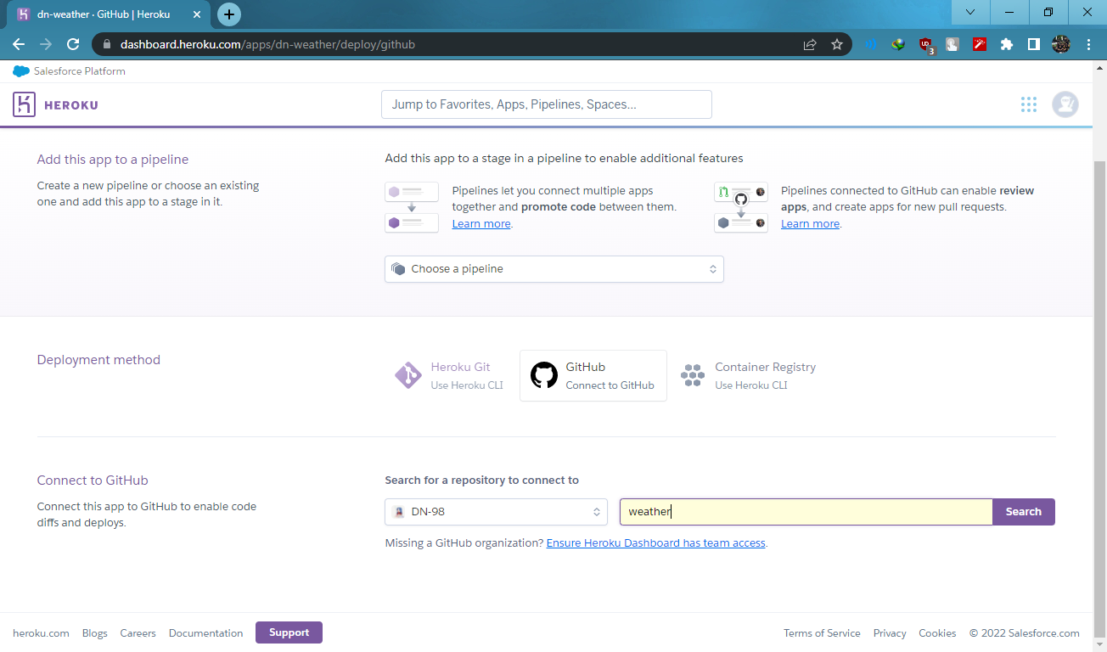

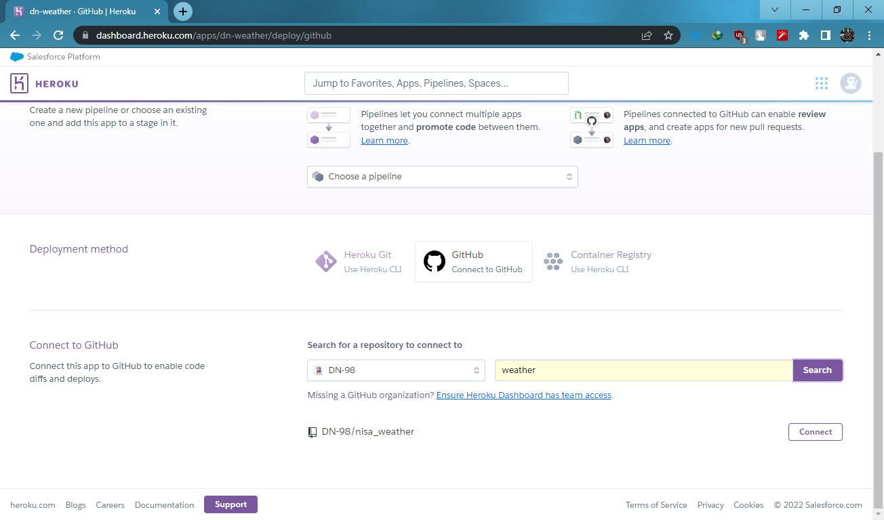

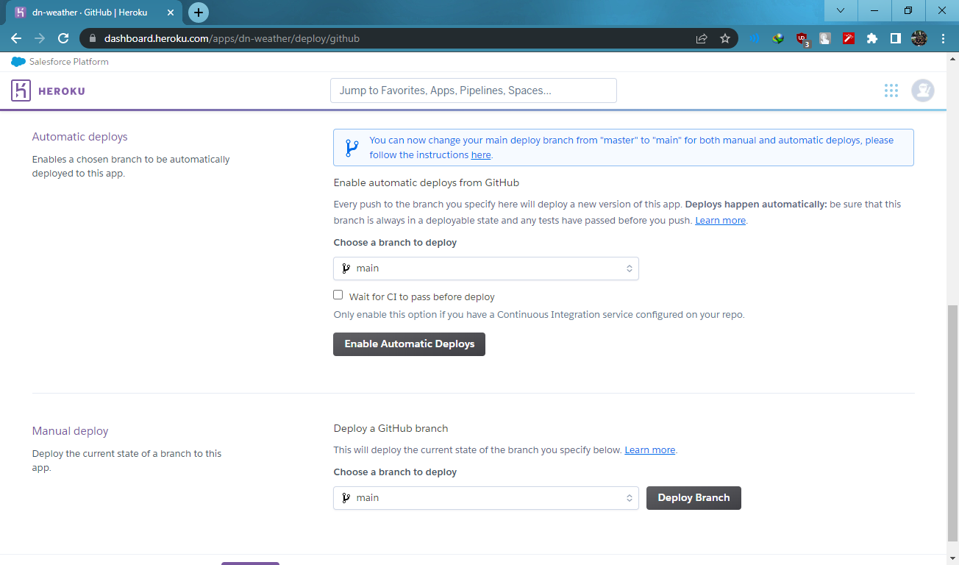

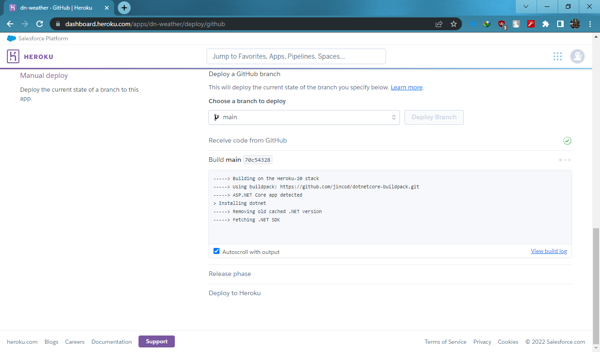

<https://dini-weather-test.herokuapp.com/swagger/index.html> deployed to Heroku